Annotate which education group spends most and which falls below the benchmark.

Scene 2 – Education’s Impact on Spending
Title: Customer Spending by Education Level
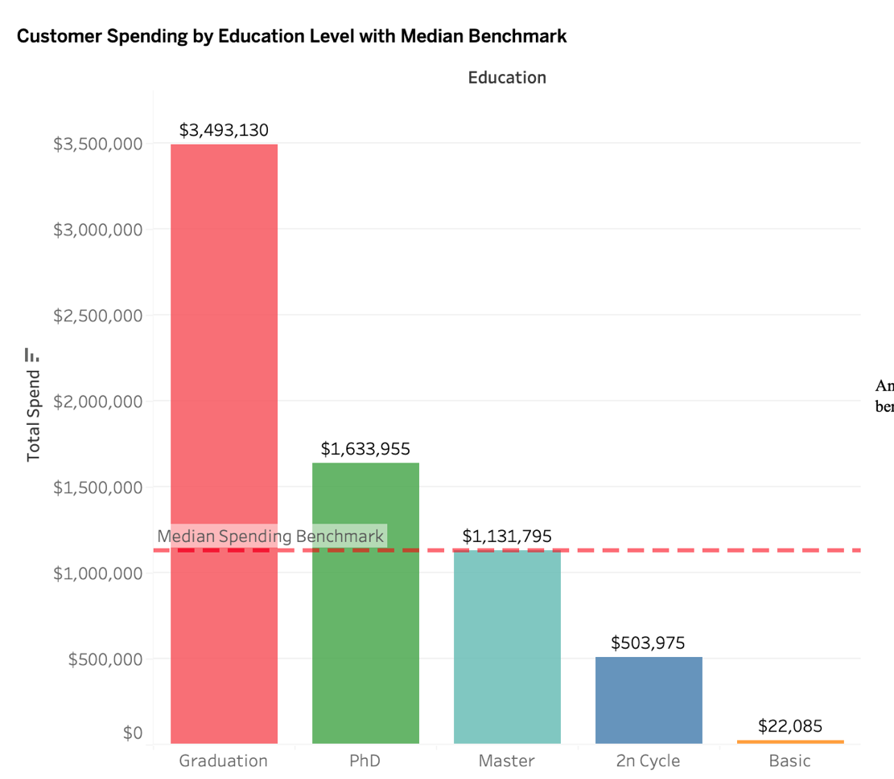

I NEED TO :
Annotate which education group spends most and which falls below the benchmark.
I WILL ALSO FILTER IT IN EDUCATION LEVEL AND MARITAL STATUS LEVEL
- ABSURD -GRADUATION IS AT 6080 AND MASTERS IS 5848

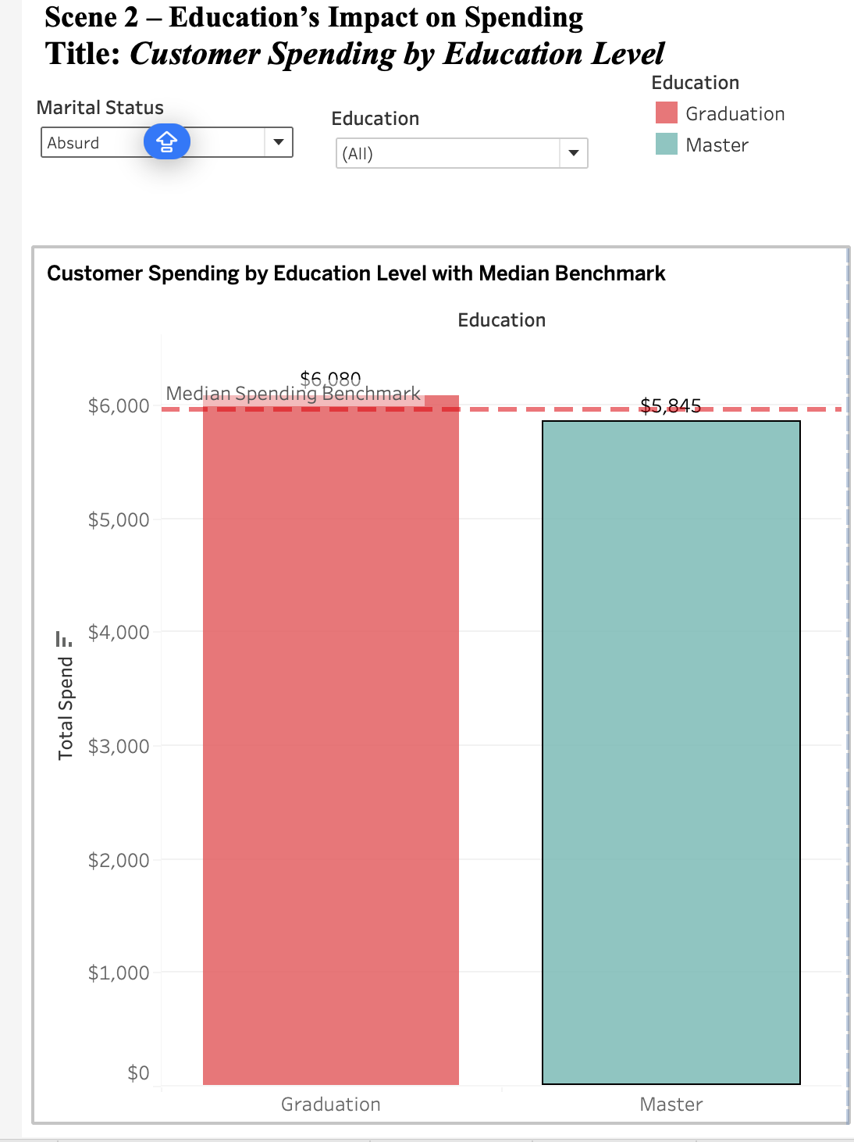
ALONE
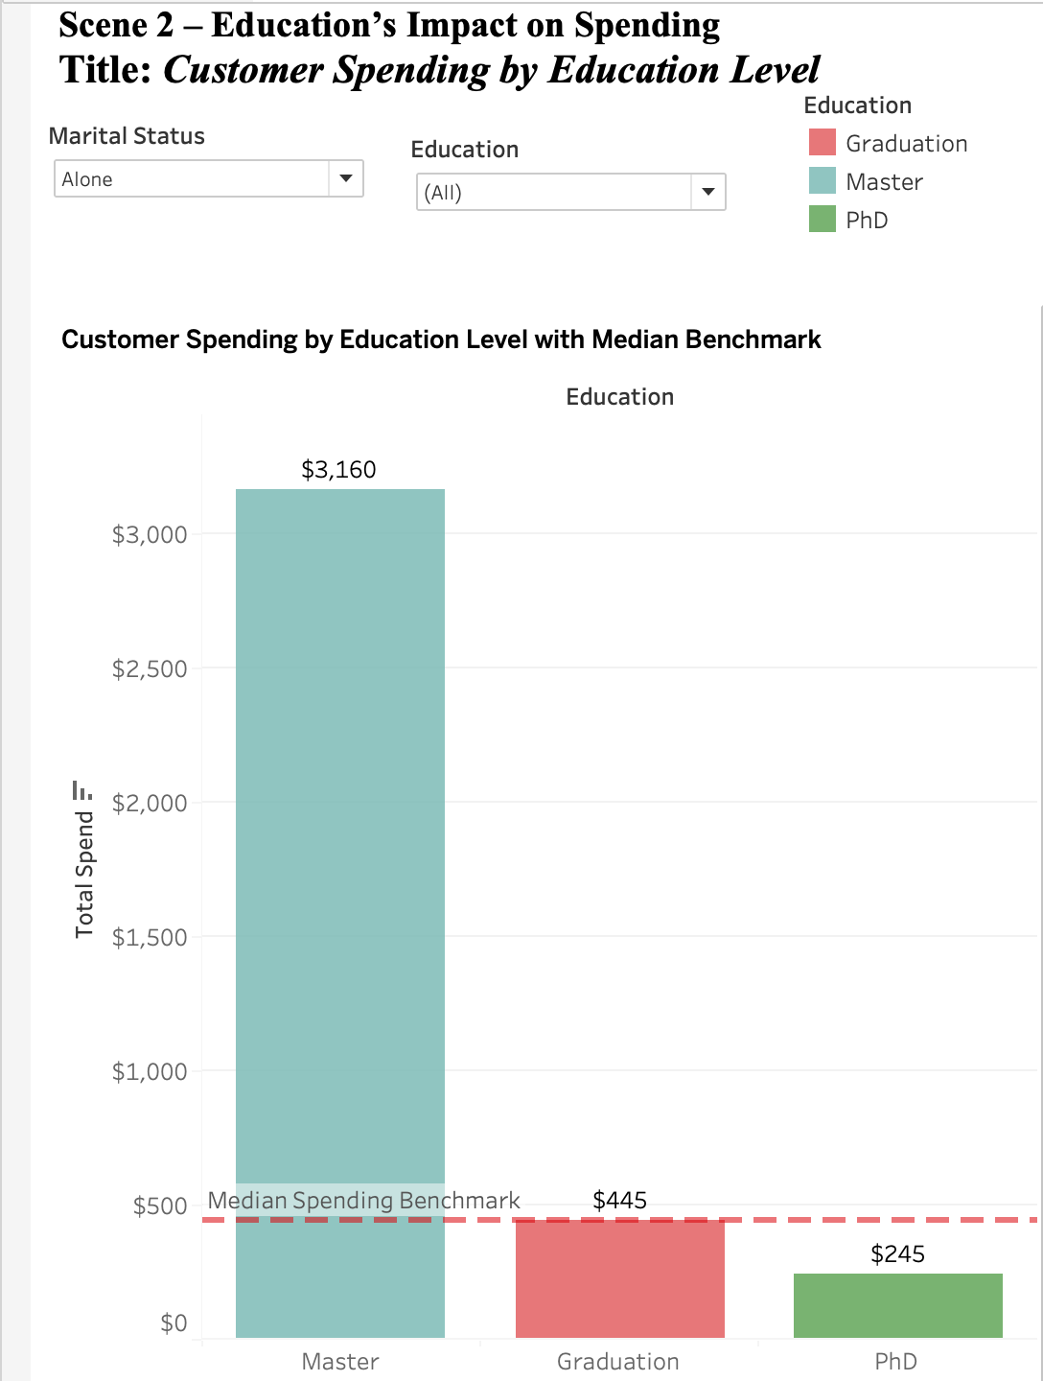
DIVORCED
